Autolab with Test Services User Manual

Autolab with Testing as Services is created for a Quicken user who can test the application with his / her own test data with the help of automation scripts without any scripting knowledge.

**Simple steps to start the process**:

1. Step 1 : User should fill the ‘WorkSheet’ of the Test data xls (e.g. For Smoke Test it would be “SmokeTestData.xls”) for system configuration setup with available options. Please refer the below example for Smoke Test and details:.

|  |  |  |  |  |  |  |
| --- | --- | --- | --- | --- | --- | --- |
| Email Address | Project Name | Build Label | Test Set | SKU | OS | Data File |
| puja_verma@intuit.com | QW12 | 21.1.7.18 | Quicken_Smokes_Desktop (1 Machine) | Quicken Rental Property Manager | WinXPSP2 | Smoke.QDF |

**Email Address** : Enter you email address to get request confirmation and result summary email.

**Project name**: Fill the project name, which Quicken you would like to run the test suit. Available options are:

* QW11
* QW12

**Build Label** : which Quicken build (version) you would like to run suit. So far available options are

* 21.1.7.18
* 21.1.7.17
* 21.1.7.16
* 21.1.7.15

**Test Set**: Please enter ‘Quicken_Smokes_Desktop (1 Machine)’ to run the smoke test.

**SKU**: All the five SKUs are available write in sheet which you want run the test.

* Quicken Rental Property Manager
* Quicken Premier
* Quicken Home and Business
* Quicken Deluxe
* Quicken Starter Edition

**OS**: Which OS(operating system) you would prefer to run the test, please select the available options.

* WinXPSP2
* WinXPSP3
* Win7Enterprise64SP1
* Win7EnterpriseSP1
* VistaEnterpriseSP1
* VistaEnterprise64SP1

**Data File:** Name of .QDF data file.

2. Step 2 : You can modify the test data of ‘Smoke test data.xls’ the available tabs in excel file as per your test requirement.

**Note** : Make sure you should not change the format of the excel, otherwise excel may corrupt.

3. Step 3: Place the excel file in location: \\mtvfsalab01\tests\Quicken\AL_Input_Files

4. Within 10 mins User will get the request confirmation notification. Example

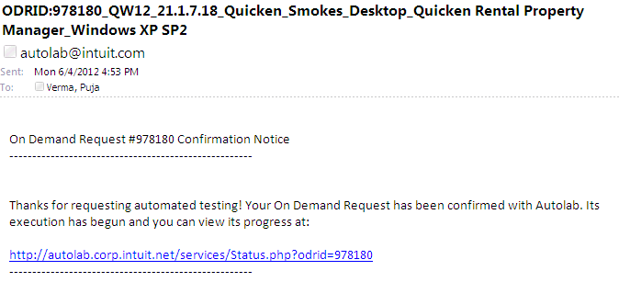

5. You can check your request status in mentioned link in email.

6. Once your test execution is completed, User will get result summary status email.

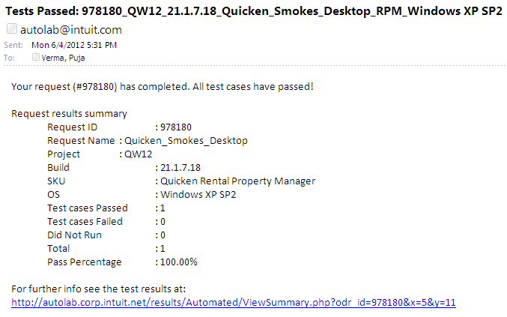

7. You can check details execution status to click test result link mentioned in email. Example

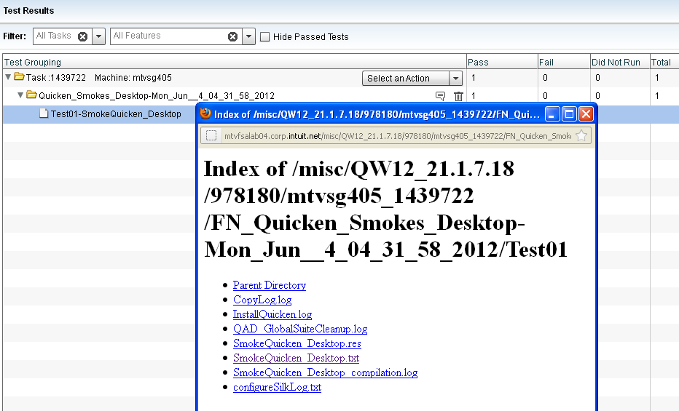

Note : Please refer the excel ‘Smoke test data’ excel sheet (.xls) for your request.